React Lab Report - OfficeSpaceRentalApp

# Introduction

This lab explored JSX and inline styling by creating a basic office rental portal using React.

# Objectives and What I Learned

- Use JSX syntax to define React components

- Use inline CSS in JSX

- Use JavaScript expressions within JSX

- Loop through arrays using map()

- Conditionally apply styling based on data

# Hands-on Practice Summary

Created 'officespacerentalapp' to show office listings using JSX and inline CSS. Used conditions to apply red or green text based on rent.

# Code Snippets

**App.js**

import React from 'react';  
function App() {  
 const heading = <h1>Office Space Rental App</h1>;  
 const imageUrl = process.env.PUBLIC_URL + '/office.jpg';  
 const office = { name: "Tech Park", rent: 65000, address: "Chennai" };  
 const offices = [...];  
 return (  
 <div>  
 {heading}  
 <img src={imageUrl} style={{ width: "600px", height: "300px" }} />  
 ...  
 </div>  
 );  
}  
export default App;

# Screenshot

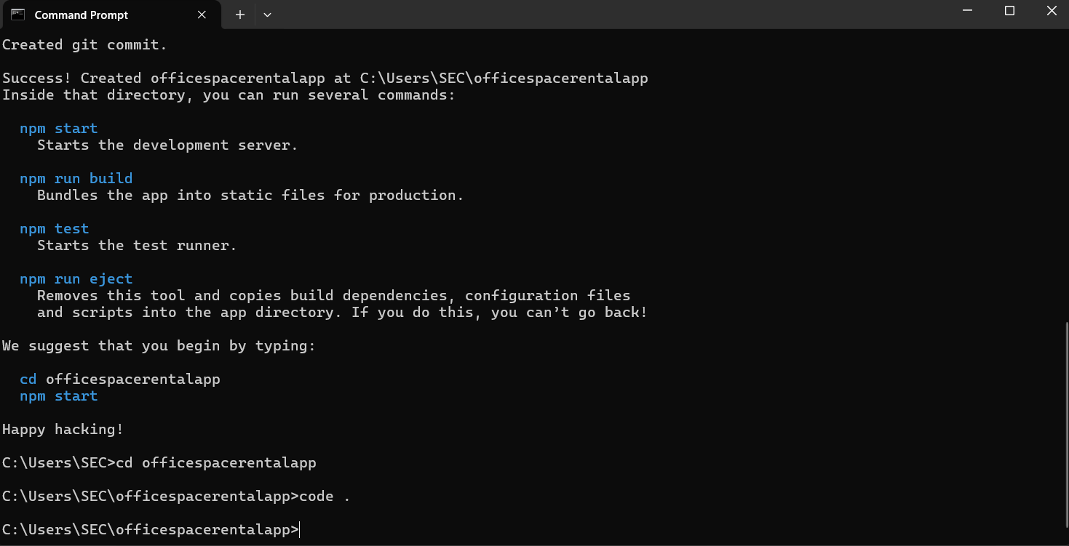

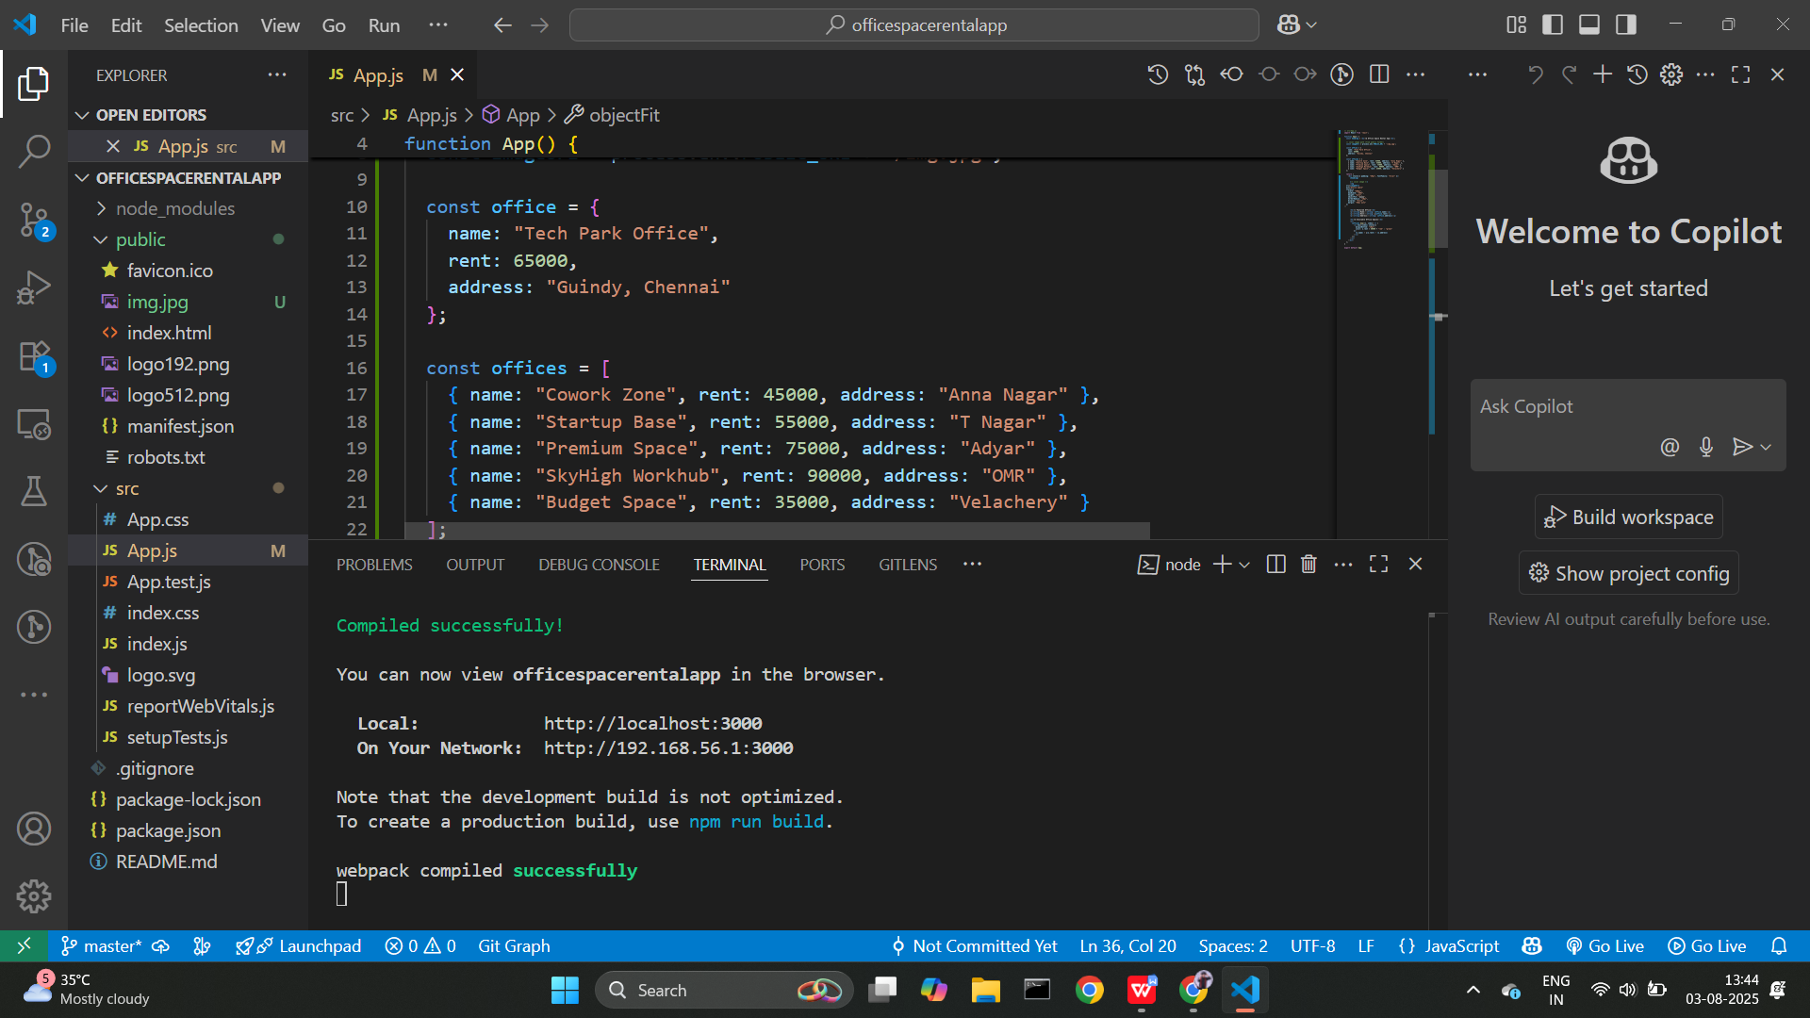

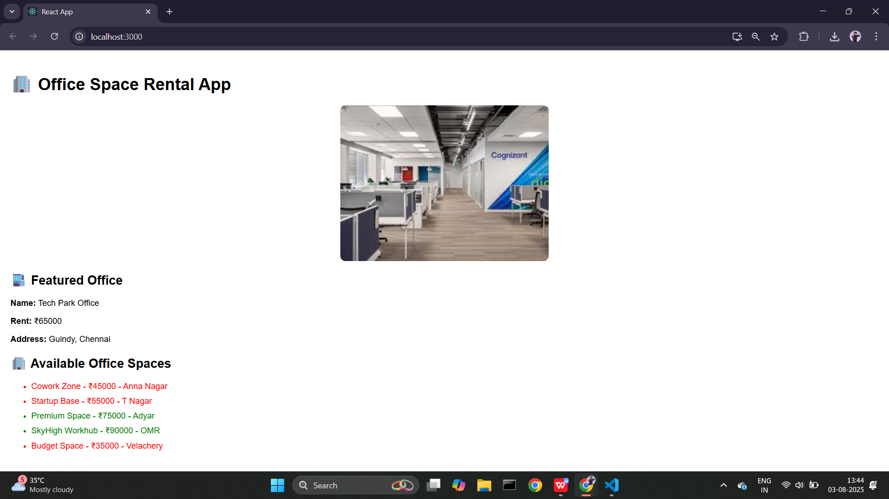

# Conclusion

This hands-on lab helped me understand JSX and inline CSS, enabling me to dynamically style content using JavaScript expressions.